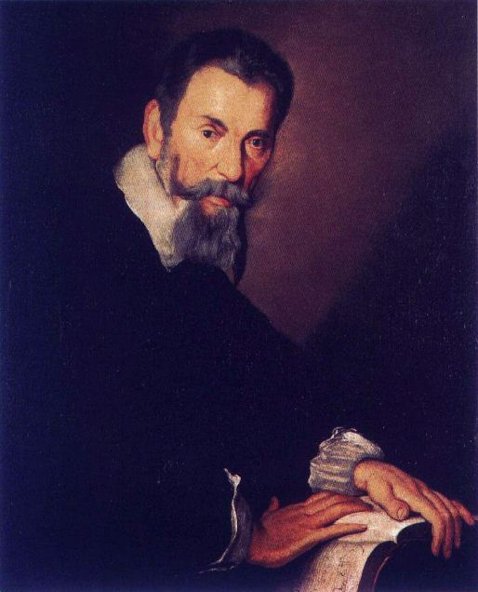

Monteverdi [-ve_r-] (Monteverde), Claudio, 1567–1643, italiensk tonsättare. M:s första kompositioner publicerades redan 1582. Åren 1590–1612 var han anställd hos hertigen av Mantua, först som instrumentalist och från 1601 som hovkapellmästare. Under denna tid tillkom flera betydande verk, bl.a. operorna Orfeo (1607) och Arianna (1608; endast bevarad i fragment) samt ett av kyrkomusikens märkligaste verk: Mariavesper (1610; tonsättningar av mässan, Magnificat och motetter för firandet av jungfru Maria). Från 1613 till sin död var M. kormästare vid Markuskyrkan i Venedig. En rad sceniska verk beställdes, bl.a. av hans forne uppdragsgivare, hertigen av Mantua. Av dessa verk finns endast ett fåtal libretton bevarade, medan musiken till största delen gått förlorad. I och med de kommersiella operascenernas uppkomst i Venedig fick han i uppdrag att skriva flera helaftonsoperor, bl.a. Odysseus återkomst (1640) och Poppeas kröning (1643), vilka tillsammans med "Orfeo" är de enda av hans operor som finns komplett bevarade. Med "Orfeo" fick operaformen sitt första konstnärligt övertygande verk, och med "Poppeas kröning" revolutionerade M. själv den unga konstformen; det är ett verk som än i dag framstår som modernt. Här ledde han musikdramatiken in på nya vägar med gudar och allegoriska figurer som fick träda tillbaka till förmån för rent mänskliga, psykologiskt nyanserade gestalter.
M:s musikaliska stil kom under 60 år att utvecklas i ständig variationsrikedom, med en produktion omfattande alla samtida musikstilar, utom ren instrumentalmusik. M. utvecklade den italienska renässansmadrigalen i riktning mot barocken i nio betydande samlingar publicerade 1587–1651. M:s uppfattning om föreningen mellan text och musik var att den skulle sträva till att "röra känslor". Den av honom skapade stile concitato, en stil i vilken människans olika sinnesstämningar skulle beskrivas i musik, användes första gången i Il combattimento di Tancredi e Clorinda (1641). Man finner sångstämmor med stark uttryckskraft realiserad med hjälp av dissonant harmonik, scenisk stile rappresentativo och polyfon satsfaktur. Anders Wiklund

Litt.: D. Arnold, Claudio Monteverdi (sv. övers. 1985); G. Tomlinson, Monteverdi and the End of the Renaissance (1987).


Epoch: Early Baroque
Country: Italy

Claudio Monteverdi (1567-1643)

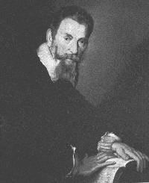 | Detailed Information about  - Picture Gallery  - List of Works  - Bibliography

Introduction
(born Cremona, 15 May 1567; died Venice, 29 November 1643).
He studied with Ingegneri, maestro di cappella at Cremona Cathedral, and published several books of motets and madrigals before going to Mantua in about 1591 to serve as a string player at the court of Duke Vincenzo Gonzaga.
There he came under the influence of Giaches de Wert, whom he failed to succeed as maestro di cappella in 1596. In 1599 he married Claudia de Cattaneis, a court singer, who bore him three children, and two years later he was appointed maestro di cappella on Pallavicino's death. Largely as the result of a prolonged controversy with the theorist G.M. Artusi, Monteverdi became known as a leading exponent of the modem approach to harmony and text expression. In 1607 his first opera, Orfeo, was produced in Mantua, followed in 1608 by Arianna. Disenchanted with Mantua, he then retumed to Cremona, but failed to secure his release from the Gonzaga family until 1612, when Duke Vincenzo died. The dedication to Pope Paul V of a grand collection of church music known as the Vespers (1610) had already indicated an outwardlooking ambition, and in 1613 Monteverdi was appointed maestro di cappella at St. Mark's, Venice.
There Monteverdi was active in reorganizing and improving the cappella as well as writing music for it, but he was also able to accept commissions from elsewhere, including some from Mantua, for example the ballet Tirsi e Clori (1616) and an opera, La finta pazza Licori (1627, not performed, now lost). He seems to have been less active after circa 1629, but he was again in demand as an opera composer on the opening of public opera houses in Venice from 1637. In 1640 Arianna was revived, and in the following two years Il ritorno d'Ulisse in patria, Le nozze d'Enea con Lavinia (lost) and L'incoronazione di Poppea were given first performances. In 1643 he visited Cremona and died shortly after his retum to Venice.
Monteverdi can be justly considered one of the most powerful figures in the history of music. Much of his development as a composer may be observed in the eight books of secular madrigals published between 1587 and 1638. The early books show his indebtedness to Marenzio in particular; the final one, Madrigali guerrieri et amorosi, includes some pieces 'in genere rappresentativo' - Il ballo delle ingrate, the Combattimento di Tancredi e Clorinda and the Lamento della ninfa - which draw on Monteverdi's experience as an opera composer. A ninth book was issued posthumously in 1651.
Orfeo was the first opera to reveal the potential of this then novel genre; Arianna (of which only the famous lament survives) may well have been responsible for its survival. Monteverdi's last opera, L'incoronazione di Poppea, though transmitted in not wholly reliable sources and including music by other men, is his greatest masterpiece and arguably the finest opera of the century. In the 1610 collection of sacred music Monteverdi displayed the multiplicity of styles that characterize this part of his output. The mass, written on themes from Gombert's motet In illo tempore, is a monument of the prima prattica or old style. At the other extreme the motets, written for virtuoso singers, are the most thorough-going exhibition of the modern style and the seconda prattica.
Extracted with permission from
The Grove Concise Dictionary of Music
edited by Stanley Sadie
© Macmillan Press Ltd., London.

This project was created by Matt Boynick.
© 1 February 1996

Classical Music Pages Homepage
Last Revision - 10 October 2000

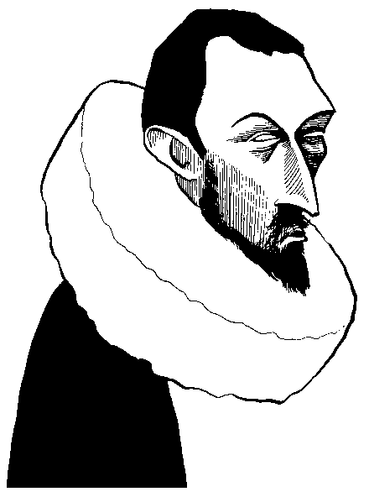
Monteverdi, Claudio (1567 - 1643)

Born in Cremona in 1567, Claudio Monteverdi served at the court of the Dukes of Mantua from the early 1590s until 1612, when he moved to Venice as maestro di cappella at the basilica of St. Mark, a position he retained until his death in 1643. His importance as a proponent of the so-called seconda prattica, the new concerted music characteristic of the early Baroque, is unquestioned, as is his pre-eminence in the development of the new form of opera that sprang from the combination of music and rhetoric in the art of Italian monody.

Stage Works
The earliest opera to retain a place in modern repertoire is Monteverdi's L'Orfeo, a dramatic version of the story of the legendary Orpheus, the musician who sought to bring his beloved Eurydice back from the Underworld by the power of music. This was written for the court of the Duke of Mantua in 1607, with a libretto by Alessandro Striggio. A second opera of the period, L'Arianna, dealing with the fate of the Cretan princess Ariadne, deserted on the island of Naxos by the Athenian prince she had rescued, Theseus, is lost, although the famous Lament of Arianna survives both as a solo song and in the form of a madrigal. The words are by the Florentine nobleman Ottavio Rinuccini, who provided the text for the ballet Il Ballo dell'ingrate. Il Combattimento di Tancredi e Clorinda (The Combat of Tancredi and Clorinda), a setting of an episode in Tasso's Gerusalemme liberata, allows Monteverdi to exhibit his newly developed stile concitato (agitated style), in an interpretation of ancient Greek philosophical principles expressed by Plato. To stile concitato is added stile molle (soft style) for humility, and stile temperato (moderate style) to represent that human emotional state. Monteverdi's last two surviving operas are Il Ritorno d'Ulisse in patria (The Return of Ulysses to his Native Country), staged in Venice in 1640, and the final L'incoronazione di Poppea (The Coronation of Poppaea) of 1642, set in imperial Rome in the time of Nero, whose love for the courtesan Poppaea is the subject of the opera.

Secular Vocal Music
Monteverdi published a number of collections of songs and madrigals. Of these the Lament of Arianna has been mentioned, while the Combattimento di Tancredi e Clorinda was also published in a set of Madrigali guerrieri et amorosi (Madrigals of War and of Love), designed for singing without dramatic action. This particularly rich repertoire of vocal music includes the duet, also in the form of a five-part madrigal, Zefiro torna (Zephyr, turn), from the poet Petrarch and Ecco mormorar l'onde (Lo the murmur of the waves), a setting of Tasso. These and other songs and madrigals by Monteverdi were brought to modern attention by the French composer, teacher and musicologist Nadia Boulanger in memorable realisations and recordings in the 1940s. | Recommended Recordings  Lament  Naxso 8.553317  Canzonette  Naxos 8.553316  Ballo delle ingrate / Combattimento di Tancredi e Clorinda  Naxos 8.553322

Church Music
Possibly as an advertisement of his varied abilities as a composer, Monteverdi wrote in 1610 a setting of the service of Vespers for the Blessed Virgin Mary in the modern style that would appeal to the officials of St. Mark's in Venice. At the same time, perhaps with a view to possible employment in the more conservative papal service in Rome, he wrote a six voice Mass setting in the old style. The Vespers offer a dramatic and colourful exploitation of the possibilities of the new style in a work of great variety and interest well suited to the spacial effects available to performers in the great basilica of St. Mark, with its galleries and traditions of writing for contrasted groups of performers spacially separated. | Recommended Recording  Vespers (1610) (2 CDs)  Naxos 8.550662-3

Cladio Monteverdi
Born: May 15, 1567. Cremona, Italy
Died: November 29, 1643. Venice, Italy.
The leading composer of the late Renaissance and Early Baroque, and the first great composer of operas. Although Monteverdi can be viewed as both a composer of the Renaissance and of the Baroque, there is a continuity that runs through his works in both styles. Monteverdi was a dramatic composer, bringing a depth of meaning from the text he set that turned each of his pieces into a convincing musical and dramatic statement.
Monteverdi's career began at an early age. He published his first pieces, a collection of three-voice motets, at the age of fifteen. By 1591, when he went to Mantua as a musician for the Gonzaga court, he had already published books of "spritual madrigals" (1583), canzonettas (1584) and his first two books of madrigals (1587 and 1590). In Mantua he continued writing madrigals, and in 1607 produced his first work in the new genre of opera, his setting of Orfeo. In 1613, he was appointed maestro di cappella at St. Mark's Cathedral in Venice. He remained in Venice for the rest of his life, writing music in all genres, including his final opera, L'incoronazione di Poppea (1642).
Monteverdi wrote in a style that he called the seconda prattica, a description he used to separate himself from the more conservative tradition of Palestrina and his contemporaries. For Monteverdi, the starting point was always the words. Whatever mood the words might suggest, or whatever effect a single word needed to convey, was reflected in the music. This is the basic idea of word painting used in madrigals throughout the century. For Monteverdi, however, it was not an isolated effect, but an absolute guiding force. This ideal permeated his madrigals and found new expression in the dramatic language of opera. All these techniques work together to make Monteverdi one of the true geniuses of Western music.

