Arvo Pärt (1935- )

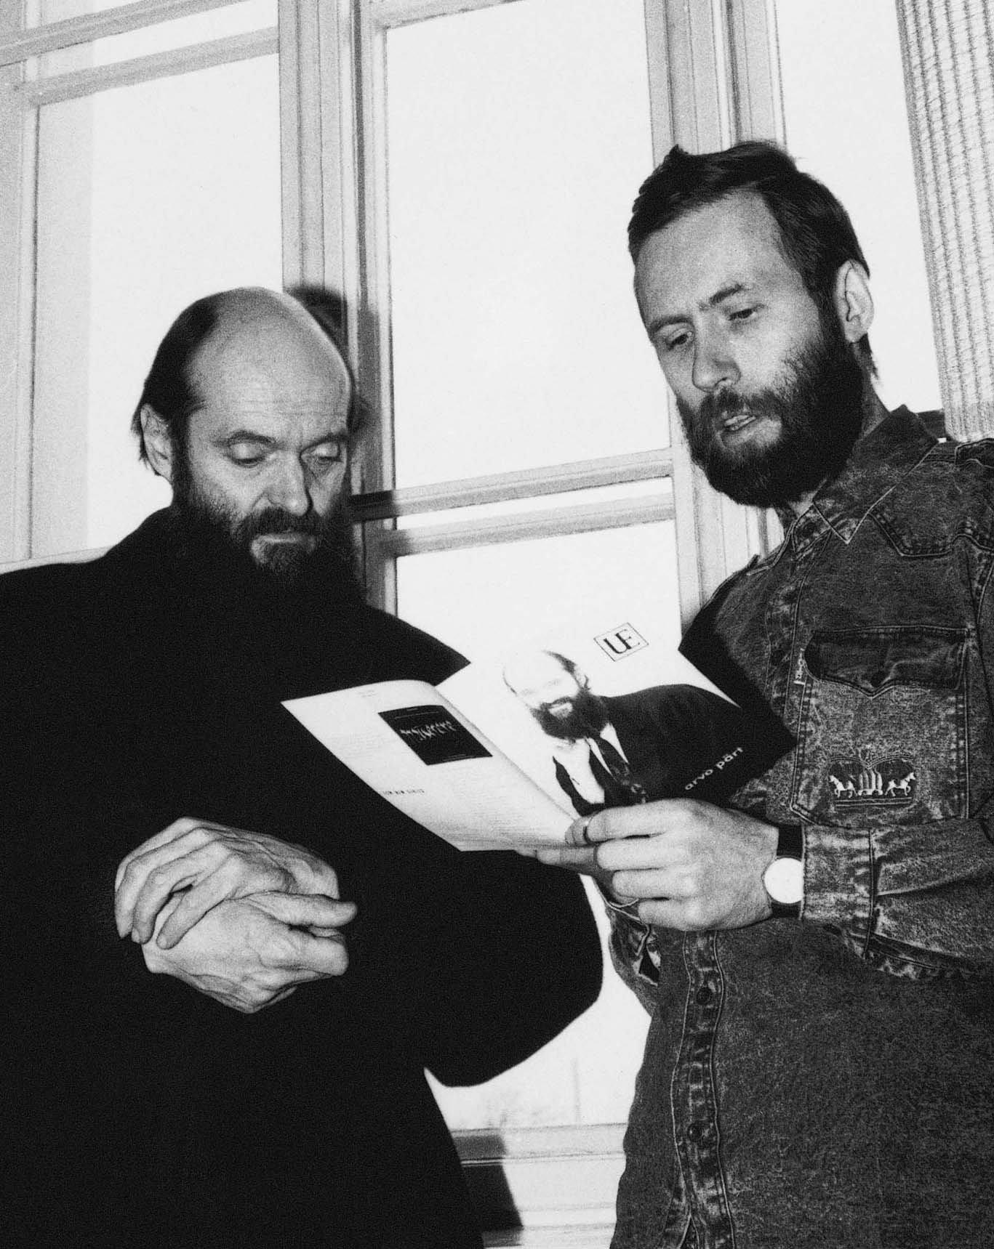

Johannes Westlund
8B, Grupp 1
Internationella Engelska Skolan
Linköping

A composers childhood
Arvo Pärt was born in an Estonian village named Paide year 1935. When the year hcelebrated his third birthday his parents divorced and Arvo was bought up by his mother. At an age of eight he stared to take regularly piano lessons because his mother and stepfather decided to move to a house in Rakvere containing a concert grand. Soon after he had begun to take lessons he found out that the pieces he was given did not satisfied him, so he started to write his own music pieces, mainly for piano but also for other instruments.
When Arvo still lived in Ravere he was able to hear classical music through a public speaker at a square. His music knowledge was very limited and that happening came to broad his musical visions, which was limited as an effect of the corrupted Soviet Union he grew up in.

Year 1954 he began his musical studies in compositions and music theory at the Tallin Music Middle School. Less than a year later he left the school to fulfil his National Service duty which he fulfilled as an oboist and a side–drummer in an army band. He returned to Tallin Music Middle School 1956 and resumed his studies there. In 1957 he advanced to The Tallin Conservatory. At that time he meets Heino Eller which worked as Arvo’s composition teacher.
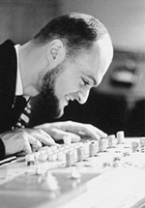
The next year, 1958, Arvo was employed as a recording engineer with the Estonian radio.
The first pieces he wrote were simple neoclassical student pieces for piano called Sonatias and A Partita.
During his time at the Estonian radio he wrote lots music for the stage and he did also receive commissions for film scores, which tells that he also wrote film scores. When he graduated in 1963 he could already e considered as a professional composer. A year before leaving his first employer he’d received 1: st prize in the All-Union Young Composers’ Competition for a children's

The musical development of Arvo Pärt
Arvo Pärt’s compositions can be divided into two major phases. The first phase starts in the late 50’s and lasts to the mid 70’s, where the second phase begins. The end of the second phase is not reached yet.

The first period
Living in the Soviet Union, Arvo Pärt had a very limited access to the western contemporary music and its developments. That isolation is clearly visible in his early music pieces.
In the 60´s Estonia saw many new revolutionary methods of composition music being introduced to use, and in the force line of the musical revolution was Arvo Pärt. Nekrolog was the first Estonian that used the serial technique. It was Pärt’s first orchestral work. Arvo continued with serialism until the middle of the 60’s. and he wrote pieces as 1st and 2nd symphonies and perpertuum Mobile.
Soon Arvo got ultimately tired of the serialism’s rigours and moved on to experiment pieces such as Collage on B-A-C-H which he wrote with the collage technique. Pärt’s collage technique involved different composers work to create a music piece, for example collage on B-A-C-H involves Bach’s Sarabande. During this period in Pärts life he’d explored many other styles such as pointillism and aleatoricism. Later on he made experiments in the limits of baroque and classic music and did also combine them.

The official judgement of Pärt’s work was very varied and while certain pieces where praised, other’s where banned. Some of his work was very nice and “correct” to its certain style, while other sounds like recorded by beginners that just was “jamming” together. In some work Pärt uses dissonances to create god knows what spirit. //Could include my own judgement here//.

To take a good example on a banned piece of work, Credo, written in 1968. This is proved to be the last composition of the collage technique, and then Pärt entered the first of his creative silence periods, also spending is time studying Notre-Dame organum, French and Franco-Flemish choral part music from the 14th and 16th centuries, including composers as Machaut, Ockeghem, Obrect and Josquin.
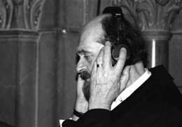
After this first period of silence he re-emerged in 1971 with Symphony NO. 3, which was completely different from his earlier pieces. Part uses a polyphony that can be traced to Dutch and it includes both the medieval and the classic element, in the respectively areas of rhythm and melody. Unlike his other previous pieces, which not where calm or slow, this piece is peaceful and makes a calm, introspective approach. Here it’s clearly visible that he finally let the serialism go for a new, calmer approach and style. However, Pärt is not yet ready to abandon his search for his true music voice. 1972 he made a new composition called Lied an die Geliebete, which was a symphonic cantata, and then entered another period of silence.

The new voice of Arvo Pärt
After four years Pärt re-emerged, when he’d found the new voice he was searching for during his silence. His new voice was building on open intervals, widely spaced pitches and Pedal tones. The picture below is from Für Alina, which is Pärt’s first composition with his new method.

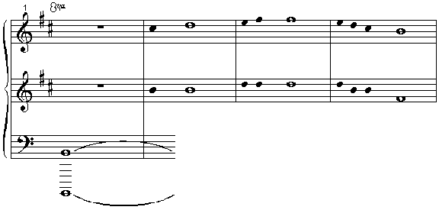

Arvo Pärt Für Alina © 1990 by Universal Edition A.G., Wien. All Rights Reserved. Used by permission of European American Music Distributors Corporation, sole U.S. and Canadian agent for Universal Edition, A.G., Wien.

He did also use the tintinnabulation technique the first time in the Für Alina composition. Pärt himself states about this composition: “That was the first piece that was on a new plateau. It was here that I discovered the triad series, which I made my simple, little guiding rule”.
Pärt refers to his new style as “tintinnabuli”. That is simply various inversions of a certain chords. Pärt’s own definition is a little bit more complex:

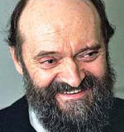
“Tintinnabulation is an area I sometimes wander into when I am searching for answers - in my life, my music, my work. In my dark hours, I have the certain feeling that everything outside this one thing has no meaning. The complex and many-faceted only confuses me, and I must search for unity. What is it, this one thing, and how do I find myway to it? Traces of this perfect thing appear in many guises - and everything that is unimportant falls away. Tintinnabulation is like this. . . . The three notes of a triad are like bells. And that is why I call it tintinnabulation.”

Arvo Pärt’s second musical phase
In the work that Pärt did after 1976 there is one underlying theme: the numinous. Here he tries to make an approach to religion and this have given humbleness in his artistic aims. His music is said to mirror the sadness of Mary when Jesus was executed at the cross “to give mercy and forgiveness to the entire world”. Sandner states:

"In a world in which Christian ideals are not universally acknowledged, this state of suffering (of the Passion of Christ without which all that comes after Christ cannot occur) is not one that must be artificially created."

Pärt wrote powerful melodies to create passion and grace. The compositions were only restricted by a few notes and he used //////“treklanger”/////. Sadner made another statement where he said that Arvo Pärt’s music is cryptic sparse and that it orbits around the words “silent”, beautiful and minimal.
Sadner’s opinion is that it is impossible to describe the separate meaning of each dissonance Pärt used in his compositions. His “post 1976” work is the work that is actually is what made him famous.

